**ME 361 LAB REPORT**

|  |  |  |
| --- | --- | --- |
| Experiment number | : | 4 |
|  |  |  |
| Sub-Group number | : | A4 |
|  |  |  |
| Name | : | Avinash Kumar |
|  |  |  |
| Roll number | : | 150169 |
|  |  |  |
| Date & Day experiment was conducted on | : | 21st August, 2017 Monday |
|  |  |  |
| Date of submission of report | : | 28st August, 2017 Monday |

**OBJECTIVE:** To draw a Cup, By a cup drawing process and measure the drawing force.

**Questions and Answers**

**Present calculations for one set of reading and provide the tabulated results**.  
Sol:

Sample Theoretical Calculation

For diameter D=2R= 92mm, thickness t = 0.6 mm;

  
F theoretical comes out to be   
And Experimental force , 

**Strain:**



**Areal Strain:**



**Volume Strain:**



**Percentage Error:**



|  |  |  |  |  |  |  |  |  |  |  |  |
| --- | --- | --- | --- | --- | --- | --- | --- | --- | --- | --- | --- |
| **S No.** | **Diameter** |  | **Drawing Force** | **Thickness** | | **Strain** | **Area** |  | **Area Strain** | **Volumetric strain** | **% Error** |
| **Fth(N)** | **Experimental (N)** | **Initial (mm)** | **Final(mm)** | **Initial** | **Final** |  |
|  |  |  | mm^2 | mm^2 |  |  |  |
| **1** | **90mm** | **19486.23** | **3520** | **0.6** | **1.372092** | **0.597713** | **24.81** | **14.831** | **0.40225** | **-0.3669442** | **81.93596** |
| **2** |  | **27667.85** | **5120** | **0.8** | **1.431155** | **0.798211** | **24.81** | **26.4** | **-0.064** | **-0.9034284** | **81.49477** |
| **3** |  | **35319.77** | **8480** | **1** | **1.453309** | **0.998547** | **24.81** | **25.498** | **-0.02766** | **-0.4935105** | **75.99078** |
| **4** | **92 mm** | **19486.43** | **5570** | **0.6** | **1.266408** | **0.597889** | **24.81** | **26.95** | **-0.08618** | **-1.2925756** | **71.41601** |
| **5** |  | **28155.26** | **6820** | **0.8** | **1.516191** | **0.798105** | **24.81** | **19.089** | **0.23064** | **-0.458123** | **75.77717** |
| **6** |  | **36101.53** | **8790** | **1** | **1.449878** | **0.99855** | **24.81** | **23.504** | **0.05272** | **-0.3734422** | **75.652** |
| **7** | **94 mm** | **19263.94** | **4270** | **0.6** | **1.18428** | **0.598026** | **24.81** | **20.418** | **0.17708** | **-0.6242803** | **77.83423** |
| **8** |  | **28212.56** | **6050** | **0.8** | **1.402159** | **0.798247** | **24.81** | **24.08** | **0.0295** | **-0.7010006** | **78.55565** |
| **9** |  | **36091.86** | **8710** | **1** | **1.067454** | **0.998933** | **24.81** | **24.609** | **0.00816** | **-0.0587439** | **75.86713** |

1. **Variation of Theoretical and Experimental Force**
2. **How the calibration of load cell is carried out.**

**Ans: L**oad cells used today is calibrated with NIST(National Institute of Standards and Technology) standards. According to NIST suggestions, At full scale-load, the output it typically 2or 3 mV/V. i.e. one part in 500 of the excitation or one part in 333 of the excitation. Therefore, for high precision calibrations, a ratio measurement is made. An 8-1/2 digit voltmeter is used in ratio mode, which has an error limit specification for this measurement of 35 ppm for a year from calibration. This DVM also communicates with the PC by the IEE-488 bus.

1. **Sketch the load cell used and explain its working.**

**Ans:** 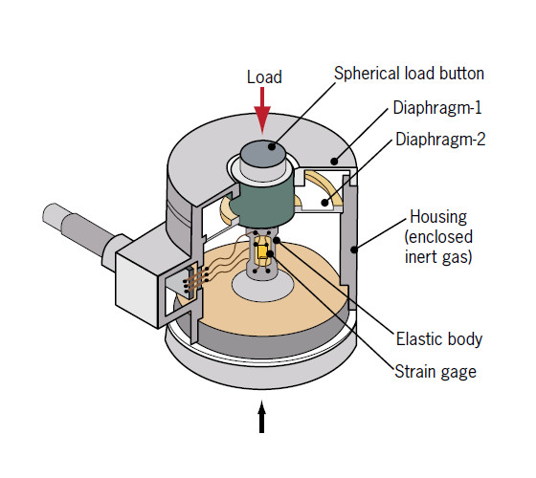

A load cell is a type of transducer (meaning that it converts one type of energy into a different type of energy) which reads an initial amount of force or weight, and then converts this force into an electrical signal.

This does not happen by way of a direct conversion, but rather occurs in two separate stages. First, the force detected effects one or more strain gauges, effectively deforming the gauges, which causes its electrical resistance to change. This relative change is then used to measure the strain. While load cells containing one or two strain gauges do exist, the most common of these devices contain four strain gauges. The output of this electrical signal is then connected to circuitry which calculates and provides a digital value of the converted electrical signal of the force or weight originally applied to the load cell.